Title

Peter Park UID: 104-766-837 Taiki Nagata UID: 505-128-821

# Introduction

The goal of this project was to build a car that follows a black path. The design used for the car consists of two primary components that control the car: the path sensors, and the motors.

A path sensor comprises an infrared LED (IR LED) and a phototransistor (the right side of Figure 1). When the sensor is atop the black path, little infrared from IR LED reflects towards the phototransistor, causing it to have a high impedance. When the sensor is atop the white field off track, a large amount of infrared reflects towards the phototransistor, causing it to have a low impedance. The phototransistor is implemented as a common-emitter circuit, in which Arduino measures the voltage across the resistor, so Arduino reads high voltage when the sensor is atop the black path and low voltage otherwise.

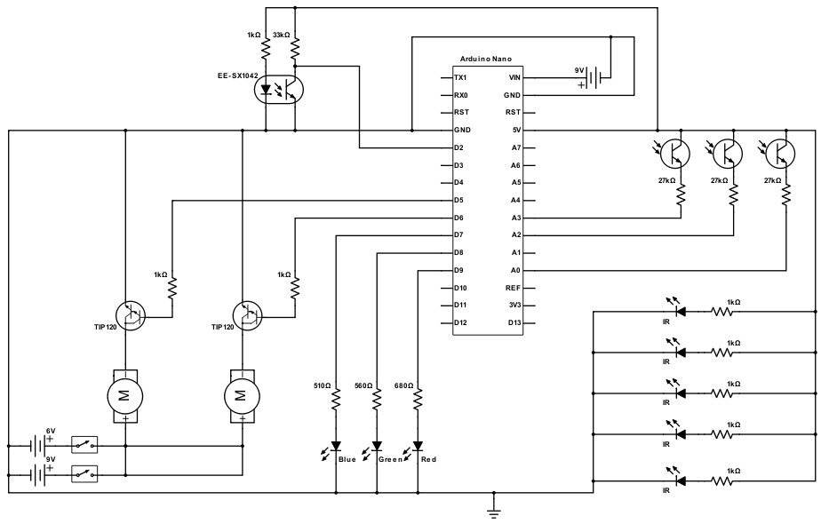

Figure : A schematic of the entire system drawn using Scheme-it [1]

The motors are controlled through the transistors, each of which is connected to Arduino's digital pin. Change in the duty cycle of the PWM signal output from Arduino's digital pins accordingly changes the rotational speed of each motor, and the difference in the rotational speed of each motor allows the car to turn.

The duty cycles of the motors are controlled by a proportional controller. [more about the controller]

# Testing Methodology

## How We Designed the Test

## How We Conducted the Test

## How We Analyzed the Test Data

## How We Interpreted the Data

# Results and Discussion

# Conclusions and Future Work

# References

|  |  |
| --- | --- |
| [1] | Digi-Key Electronics, "Scheme-it," [Online]. Available: https://www.digikey.com/schemeit/project/. [Accessed 15 August 2018]. |